# Who we are

## Germania Tek For Professional Web Development and Mobile Apps

We are a software agency based in Egypt make projects also in Germany, Syria and Iraq. We’re helping businesses of all size get a better return from online activities.



We design and build stunning bespoke websites and we can help with a wide range of online marketing strategies. Every software that we create is designed and built by our team of friendly web developers , mobile app developers you have full content management so that you can update your software whenever you wish.

# Take a look on some of our projects

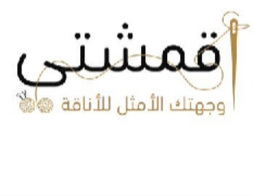

أﻗﻤﺸﱵ

Publish date: 2024 Flutter, PHP, Laravel

## Mobile app

Aqmishaty stands out as a vibrant marketplace app designed specifically for fabric enthusiasts, seamlessly bridging the gap between reputable fabric shops and discerning customers.

It boasts an intuitive platform that enriches the fabric shopping experience by offering a wide array of high- quality fabrics, exclusive deals, and personalized subscription packages.

Additionally, it integrates targeted ads to ensure users are informed about the latest trends and offers. With Aqmishaty, both shops and customers enjoy a streamlined, interactive shopping journey, complete with user-friendly features and robust support.

## CRM

Aqmishaty's dashboard is a masterfully designed interface, providing users with instant access to fabric collections, shop profiles, and personalized offers.

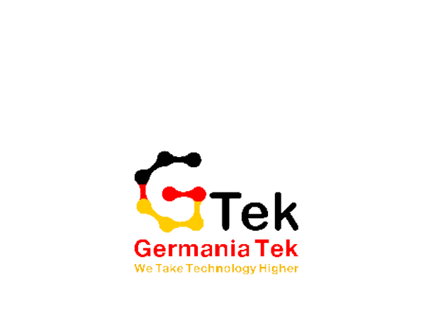It integrates real-time analytics for shops, enhancing business insights, while customers enjoy tailored recommendations. This intuitive dashboard ensures a seamless navigation experience, making fabric discovery and management effortlessly efficient.